Group-32

Harsh Patel – 100852669

Raquim Dockery 100660304

Christopher Fowler 100711442

Capstone Project DCOM 4100

Routing

Table of Contents

HO-Toronto 2

Branch-Oshawa 4

ISP-1 6

ISP-2 8

ISP-3 10

# HO-Toronto

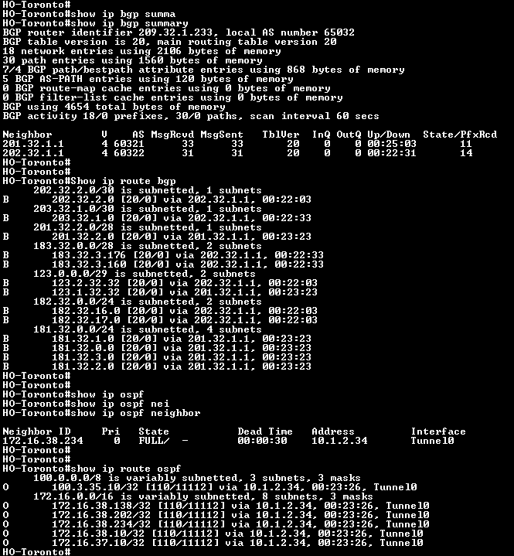

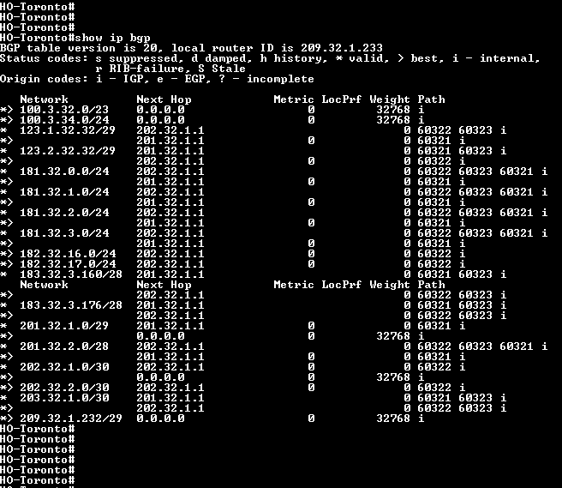

# Branch-Oshawa

# ISP-1

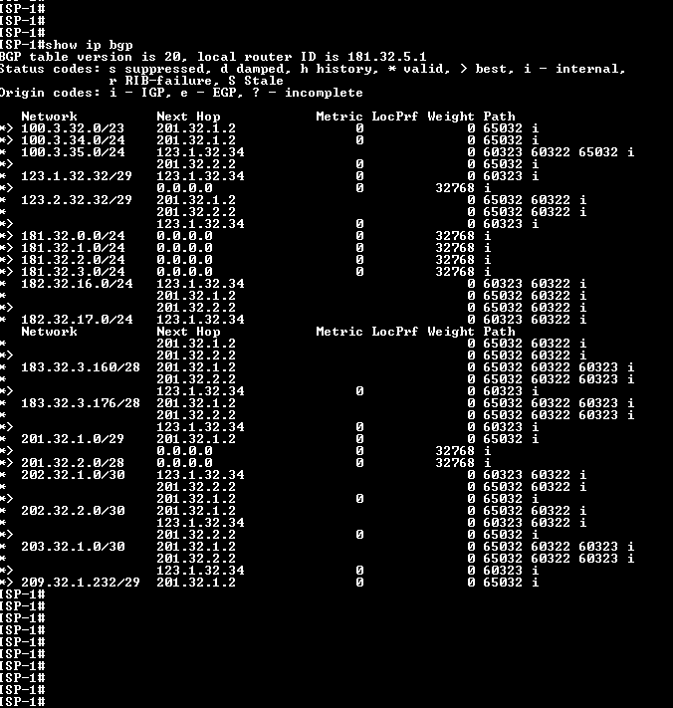

# ISP-2

# ISP-3



